Equipe du Dr MARTIN

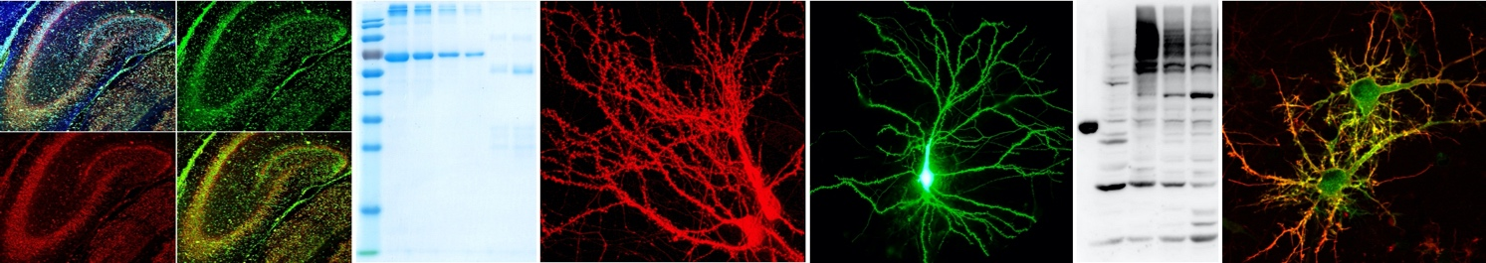

Encadrant :
Stéphane MARTIN 04 93 95 34 61 ; martin@ipmc.cnrs.fr

Sujet :

Investigating the metabotropic Glutamate Receptor-dependent regulation of the SUMO machinery in a Fragile X Syndrome context

Master 1 ou 2

Mots-clés : SUMO, trafficking, synapse, neurons, live cell imaging.

The synapse is the contact point between neurons where neurotransmission occurs. This highly specific area is a dynamic compartment where all molecular processes are orchestrated both in time and space. Among these is the activity-dependent reorganization of protein composition at synapses, which mainly occurs via modulation of protein-protein interactions and diffusion of signaling molecules in and out of spines. Such reorganization is at the basis of synaptic plasticity events and learning and memory processes. This activity-dependent shaping of the synaptic content relies mainly on post-translational modifications (PTMs) including phosphorylation or ubiquitination. In the past years, another protein modification called SUMOylation also appeared as an essential regulator of synaptic communication and plasticity (1-2). It consists in the covalent but reversible conjugation of the Small Ubiquitin-like MOdifier SUMO polypeptide to specific lysine residues of target proteins. Disruption of the SUMOylation/deSUMOylation balance in neurons leads to early lethality indicating that the regulation of this process is central to brain development.

In the past years, we have demonstrated that the SUMOylation/deSUMOylation balance is regulated by the activation of type 1 metabotropic glutamate receptors mGluRs (3-5). The overall aim of the present project is thus to assess how alterations in the mGluR-signaling pathway impact the SUMOylation/deSUMOylation balance and consequently lead to neuronal communication defects.

The selected student will use molecular, biochemical and live cell-imaging approaches to investigate the regulatory mechanisms of the SUMOylation and deSUMOylation machinery in living neurons obtained from genetically-modified mouse models of the Fragile X Syndrome in which, the mGluR signaling pathway is altered.

Publications relatives au sujet :
- 1- Martin S. et al. (2007) Nature 447:321.
- 2- Schorova L. & Martin S. Frontiers in Synaptic Neuroscience 8:9 (2016).
- 3- Loriol C. et al. Nature Communications 5:5113 (2014).
- 4- Schorova L. et al. Cellular and Molecular Life Sciences 5:5113 (2019).
- 5- Pronot M. et al. Cellular and Molecular Life Sciences 79:378 (2022).

